Chattanooga Scottish Rite News

Vol.48-No. 1

Jan-Feb-Mar 2014

ALLEGIANCE
The several Bodies of the Ancient and Accepted Scottish Rite of Freemasonry , sitting in the Valley of Chattanooga, Orient of Tennessee, acknowledge and yield Allegiance to The Supreme Council (Mother Council of the World) of the Inspectors General Knights Commanders of the House of the Temple of Solomon of the Thirty-Third Degree of the Ancient and Accepted Scottish Rite of Free Masonry of the Southern Jurisdiction of the United States of America, of which
Ronald A. Seale, 33°
Is Sovereign Grand Commander
William B. Brunk 33°
Is Grand Secretary General
Joseph C. Harrison, Jr., 33°
Is Deputy in Tennessee
William Gene Sizemore, 33°
Is Grand Executive Director
Joel L. Bremer, 33°
Is Personal Representative of the SGIG
Terry L. Plemons, 33°
Is Assistant Personal Representative of the SGIG

ADVISORY CONFERENCE
Chairman…………………………….….…..…….Joel L. Bremer, 33°
Venerable Master……….……….…..……Dennis L. Phillips, 33°
Wise Master………………………...…Johnny E. Thompson. 33°
Commander……………………….……….…....Robert E. Hall, 33°
Master of Kadosh…….……….….…………William E. Fulks, 33°
Secretary………...................................Bobby G. Green, 33°
Treasurer...……………………...….Charles T. Millirons, Jr., 33°
Past Venerable Master……………………..Joel L. Bremer, 33°
Past Wise Master………………….....…..Bobby G. Officer, 33°
Past Commander……………….….……..Terry L. Plemons, 33°
Past Master of Kadosh…………..…….Roy W. Browning, 33°
Almoner…………………………………………B. Don Aldridge, 33°

CLUBS AND SOCIETIES

CHATTANOOGA
John Spencer, 32° KCCH, President
Volney Farned, 32° KCCH, Secretary
Meeting 2nd Thursday
Dinner – 6:30 PM EDT…..……..…….…Scottish Rite Center

BRADLEY COUNTY
Van Swearingen, 32° KCCH, President
William J. Herron, 32°, Secretary/Treasurer
Meeting 2nd Tuesday, 6:30 PM EDT...Angela’s Restaurant
1799 APD 40, Cleveland, TN

FRANKLIN COUNTY

GRUNDY COUNTY
Jim Parrott, 32°, President
Bill Hargis, 33°, Secretary
Meeting 4th Monday, 6:30 PM CDT
Sewanee Lodge Hall #405………………………Tracy City, TN

MCMINN COUNTY

W. A. PRICE – MARION COUNTY
Dennis Phillips, 33°, President
Spencer Wayne, 32°, Secretary
Meeting 3rd Tuesday 6:30 PM CDT
Western Sizzlin Steakhouse……………..…………..Jasper, TN

RHEA COUNTY
Gary Whittaker, 32°, President
Clyde Caldwell, 32° KCCH, Secretary/Treasurer
Meeting 4th Monday, 6:30 PM EDT
Dayton Masonic Lodge……………………………….Dayton, TN

SEQUATCHIE COUNTY
Troy Ballard, 32° KCCH, President
Meeting 1st Thursday 6:00 PM CDT
Back Street Diner.…………………………………….…Dunlap, TN

WARREN COUNTY
David Pendergraph, 32°, President
Meeting 3rd Monday 6:30 PM CDT
VFW Club………………………………………..….McMinnville, TN

WHITE COUNTY
Fred Stouky, 32°, President
Robert Hall, 33°, Secretary
Meeting 4th Tuesday 6:00 PM CDT
Casa Luna Restaurant…………………………………..Sparta, TN

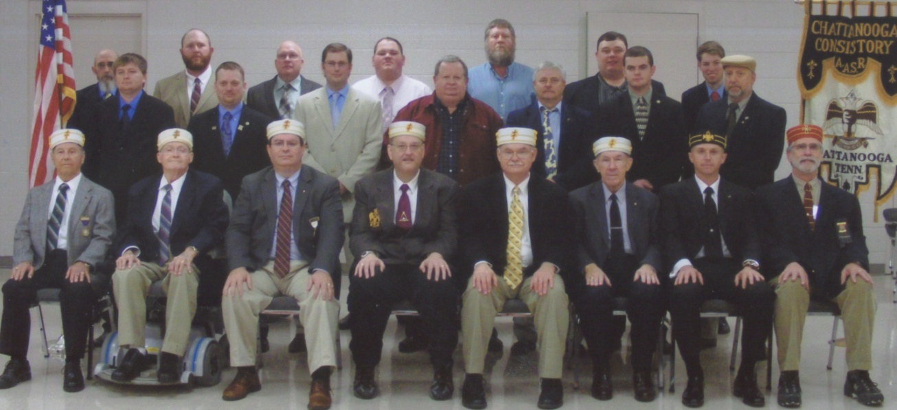
Ninety-Second Reunion - Valley of Chattanooga November 15-16, 2013
Seated (l-r): Roy Browning, 33° - Past Master of Kadosh; Bill Fulks, 33° - Master of Kadosh;
Terry Plemons, 33° - Past Commander of Kadosh; Robert Officer, 33° - Wise Master;
Joel Bremer, 33° - Personal Representative of the SGIG in TN & Venerable Master;
Robert Hall, 33° - Commander of Kadosh; Jim Pilkinton, 32° - Class Director; Jim Arnhart,
32° KCCH - General Secretary
Standing second row (l-r): John Blanton, Shane Payne, Ronald Gilchrist, Bruce Perry, David
Clemons, Jessy Riggs, Allan Kelley, Sr. Third row (l-r): Paul Lowery, Josh Brown, Kevin
Sweeton, Gerald Zigner, George Crownover, Chad Davis, Charles Googe

Top-Line Signers:
Bill Hargis, 33° - Joshua Brown Harry Paulk, 32° KCCH - John Blanton
Shane Payne
Kevin Sweeton Volney Farned, 32° KCCH - Ronald Gilchrist

Danny Creason, 32° - George Crownover Hoyt O. Samples, 33° - Charles Googe
Chad Davis Wayne Gunter, 33° - Allan Kelley, Sr.
Billie Joe Cook, 33° - David Clemons
Bruce Perry Robert Evans, 32° KCCH - Jessy Riggs

Robert Parris, 32° - Paul Lowery Terry Plemons, 33° - Gerald Zigner

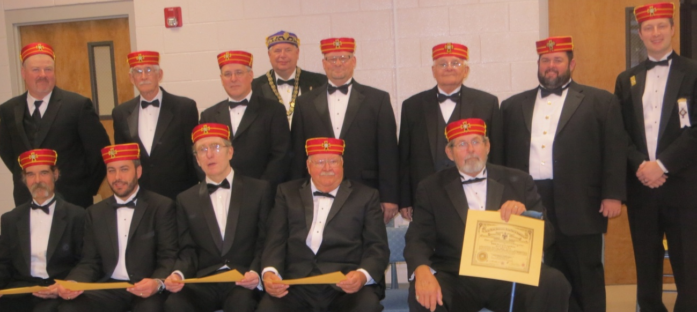

Twelve Scottish Rite Masons received the rank of Knight Commander Court of Honour
at the KCCH Investiture held on October 12, 2013. Seated (l-r) are Mike Bible, Brent Ellis,
Volney Farned, Joe Gebis, Tom Key. Standing (second row (l-r) John Lentz, Harry Paulk,
Richard Petty, Jr., John Spencer, Van Swearingen, Jamey Taylor, Lochlin Samples.
Standing on back row is Hoyt O. Samples, 33°.

****************************************************************************************************

The 33rd Conferral was held in Nashville on December 8th and the
Valley of Chattanooga had 3 members who received the 33°.
Congratulations to Johnny Thompson, Rice Crabtree, and
Dennis Wofford (pictured below l-r).

Dates to Remember
Jan. 9, 2014.. …….……Advisory Conference 5:00 pm
Society Mtg & Meal 6:30 pm
LOP Mtg 7:30 pm

Feb. 13, 2013 ………. Advisory Conference 5:00 pm
Society Mtg & Meal 6:30 pm
LOP Mtg 7:30 pm

March 13, 2013……… Advisory Conference 5:00 pm
Society Mtg & Meal 6:30 pm
LOP Mtg 7:30 pm

*************************************
A big thanks to the Chattanooga Scottish Rite Society
and Knights of Saint Andrew for donating the proceeds
of the Boston Butt Fundraiser to the Foundation!

*************************************
What shall I bring when I approach the Lord?
How shall I stoop before God on high?
Shall I offer my eldest son for my own wrongdoing,
My children for my own sin?

God has told you what is good;
And what is it that the Lord asks of you?
Only to act justly, to love loyalty,
To walk wisely before your God.
Book of Micah, Chapter 6

Then the Lord's love burned with zeal for His land,
And He was moved with compassion for his people.
He answered their appeal and said,
I will send you corn, and new wine, and oil,
And you shall have your fill.
Book of Joel, Chapter 2

Now to the One who can keep you from falling and
set you in the presence of His glory, jubilant and above
reproach, to the only God our Saviour, be glory and
majesty, might and authority, through Jesus Christ our
Lord, before all time, now, and for-evermore. Amen
Book of Jude

Joel L. Bremer, 33°
Personal Representative of the SGIG in TN
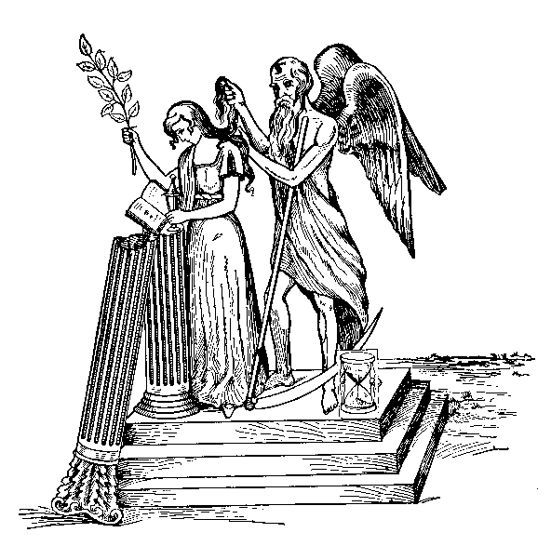

In Remembrance of Our Brothers

Robert Forster Clark, 32° KCCH
Gordon Dennis Hedgecoth, 32°
Felix Jerome Guy, 32°
Marvin Luther Waters, Jr., 32°
Charles Ross Lee, 32°
Samuel Denton Burgess, Jr.
Paul Marshal Halmontaller, 32° (50-Year)
Glenn Delane Smith, 32°

Have a safe and happy holiday
season - Merry Christmas to all!

